Leontief Medal Presentation
to Ljubo Sirc

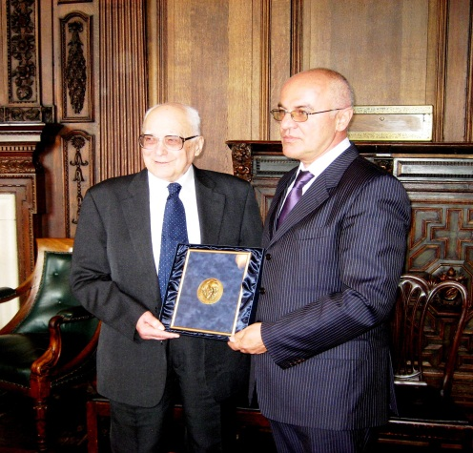

Hosted generously by the Business School of the University of Glasgow represented by the Head of the Business School, Professor Farhad Nourbakhsh (a former colleague), the Presentation of the Leontief Medal to Dr Ljubo Sirc took place in Melville Room in the beautiful Victorian surroundings of the University of Glasgow on Thursday, 12 May 2011.

Dr Sergey Vasiliev, of the Leontief Institute accompanied by his wife Marina, flew in from St Petersburg to make the presentation (pictured above). The Principal of Glasgow University, Professor Anton Muscatelli (a former student and colleague), came to offer his congratulations before the formalities began; the University was represented by Vice-Principal Professor Anne Anderson. Among the guests were family and many friends, including Susan and Nadia Sirc, Roger Clarke (editor of CRCE's Journal, Post-Communist Economies and former Glasgow colleague), Professor Roger Sandilands and his wife, Liza, Dr Eric Levin (another former student), and Lisl Biggs-Davison of CRCE.

Ministers and Massacres

Charles Crawford, who chaired the discussion at CRCE in March, writes:

“For many years I have been a friend of the Centre for Research into Post-Communist Economies, a sturdy enemy of collectivism based in deepest Westminster. They did fine work in mobilising anti-communist analysis and economic thought during the Cold War and thereafter.
This week they hosted a fine presentation and discussion led by Count Nikolai Tolstoy on the story which never dies, namely the ghastly circumstances surrounding the way British troops under the influence of Harold Macmillan handed over thousands of Russians, Yugoslavs and others to their doom through Stalin/Tito mass murdering.
Nikolai Tolstoy gave a powerful and moving account of his own long efforts to follow this story, which has taken him through a fearsome battle in the English libel courts and then the European Court of Human Rights through to the heart of the Soviet archives in Moscow (that name helped get him in!). Many of his suspicions about the actions and motives of key British and American officers involved had been confirmed in deeply buried Soviet secret documents”.
Full report available at:

http://charlescrawford.biz/blog/ministers-and-massacres

Crimes of Communist Totalitarianism: How it divided nations

In April, the CRCE together with the Study Centre for National Reconciliation (SNCR), Ljubljana, hosted an important seminar There was an impressive list of speakers including:

Andreja Valič, Director of SNCR on the idea of a British-Slovenian historical commission.
Jim Kosem & Rolf Wiesemes: The project Pervasive monument
Mateja Čoh: Freedom, King and Country
Jože Dežman The consequences of the Vetrinj tragedy
Tamara Griesser Pečar: Persecution of the Catholic Church in post-war Slovenia
John Corsellis: Dealing with a Communist past
Marcus Ferrar on A progress report on dealing with the Communist Past.
Nikolai Tolstoy: British responsibility for Slovene massacres in 1945: Cruel Necessity or Macchiavellian Conspiracy?
After lunch and animated discussion in the crowded boardroom, a petition calling for a British-Slovenian Historical Commission was presented at 10 Downing Street
Slovenian Nostalgia
In a letter to The Times, Ljubo Sirc wrote:
Sir: your report (April 4) greatly gives prominence to the shameful new Slovenian €2 coin honouring the communist partisan Franc Rozman ("Stane" was his partisan name, not his surname, as implied). Rozman is indeed widely held to have both ordered the execution of Democrats and to have killed some himself. The photo of him printed with the article shows him standing between a career officer on the left, and on the right, Viktor Avbelj, a general in the Slovenian Secret Police, who later became chief prosecutor in the infamous Nagode trial in 1947.
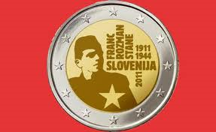
The coin in question

Chris Cviic Memorial Lecture

In May, Lisl Biggs-Davison attended the lecture at the EBRD: “Remaking the Balkans” in memory of Chris Cviic organised by the Bank and the British Croatia Association. The main speaker was Peter Sanfey, the EBRD’s Lead Economist. He and Chris co-authored In Search of the Balkan Recovery: the Political and Economic Re-emergence of South-Eastern Europe. Erik Berglof, Chief Economist at EBRD was in the Chair and Croatia’s Deputy Prime Minister, Domagoj Miloševic, also spoke. Celia Cviic was an honoured guest at the event.

Compliments for the CRCE
Rok Spruk from Ljubljana writes:
I have been closely monitoring the work of the CRCE in recent years. By any means, it is the most powerful voice in educating the public about the true nature and pitfalls of post-communist transition which is one of the most misunderstood fields in the political economy.

Thank you, Rok!

Last but definitely Not Least

Warmest congratulations to Philip Hanson who was awarded the OBE in the Queen’s Birthday Honours this year!

