The CRCE Newsletter
No. 46 Autumn 2012
57 Tufton Street, London SW1P 3QL Tel/fax: +44 (0) 20 7233 1050
email: crce@trident-net.co.uk website: www.crce.org.uk

Colloquium in Slovenia

“In my opinion the conference was a great success. Everyone seemed to enjoy themselves, the atmosphere was lively, and proceedings ran smoothly. Once again we were hosted by the delightful Pension Zaplata, who made our stay comfortable and provided delicious meals!

The theme of the colloquium was “The Lure of State Capitalism.” It incorporated three discussions; including a sub-topic on the utility and predictive power of economics as an analytical tool. In total around twenty academics attended from eleven different countries.

Tomasz Mickiewicz gave a particularly interesting talk on corruption. Continuing a topic discussed last year – whether corruption can ever be efficient – he outlined how corruption, whilst it may improve the welfare of the two parties involved, will always be inefficient. The exception is if the principal’s objectives are criminal. Only then should corruption should be accepted, because the agent would generally make better use of the money than the principal.

The colloquium ended on a discussion of the pros and cons of state capitalism. During this discussion, Roger Sandilands presented the importance of state support to optimise housing finance in China; and Silvana Malle discussed the nature of state corporatism in Russia.

On the final day we visited the historic Pirc family dye-works in Kranj. Darja Okorn made us feel very welcome, and showed us around her fascinating home. It was very interesting to see what the factory would have looked like, and we were shown examples of its work. Before our visit, Lisl took us on a tour of the town, and showed us where the UDBA had observed the Sirc family home during Ljubo’s exile. It was a very illuminating and enjoyable trip.
Annie Beadle, CRCE Intern

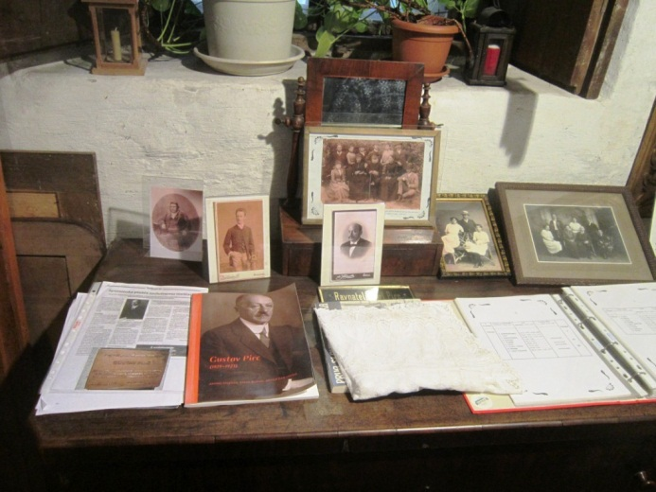
Pirc memorabilia in the Monga. Photo: R. Sandilands

Stefan Hedlund writes:
“I have particularly fond memories of our little outing to Kranj. Hope all works out fine with further financing for the lovely little museum.”

President Klaus interviewed in The Telegraph
"When it comes to the political elites at the top of the countries, it is true, I am isolated," he said. "Especially after our Communist experience, we know, very strongly and possibly more than people in Western Europe, that the process of democracy is more important than the outcome.
"It is an irony of history, I would never have assumed in 1989, that I would be doing this now: that it would be my role to preach the value of democracy."
In his book, Europe: The Shattering of Illusions, published by Bloomsbury in September, Mr Klaus makes the case that the EU has evolved into its current form because political leaders have found it convenient to turn away from their nation states, where voters have historically been able to hold them to account.
Full interview: http://bitly.com/TEj3cf

Book Review by Keith Miles OBE
Ed Vulliamy, The War is Dead, Long Live the War: Bosnia – The Reckoning, Random House

Miloslav Samardzic, Cooperation of the Partisans with the Occupiers, Zalozba Ignis (Slovenia)

It may seem strange to review these two books at the same time, but it is interesting to associate these two books in a review.

Ed Vulliamy quite correctly recognises that history can be re-written or even only written by the winners or those in power, and he correctly traces some of the despicable actions by the Bosnian Serbs back to similar cleansing by the Nazis.

Since the break-up of Yugoslavia archives have been opened and much new evidence has come to light of the wartime history. After Yugoslavia left the Soviet orbit the west largely left Tito alone in the propaganda war of the Cold War which left him and his communist friends to write the history of their so-called ‘war of liberation’ as they wished.

In fact we now know that the primary objective of the Yugoslav communists as disciples of Stalin was to achieve a communist takeover through the means of a civil war and then to carry out a Bolshevik revolution. Once one places this objective in the leading position their actions however disgraceful and disgusting become clear. The Samadzic book records with documents and pictures the constant and widespread cooperation of the partisans with all types of forces in Yugoslavia: Germans, Italians, Ustashi, Albanians and of course the Allies. The communists clearly saw all these as enemies but useful to collaborate with in their revolutionary struggle for power. Indeed the ones they found most difficult to cooperate with were the other Yugoslav resistance forces.

The book reminds us that the Yugoslav communists cooperated in the 1930s with the Ustashi against Royalist Yugoslavia and with the Nazis in the period after the attack on Royal Yugoslavia and up to the German attack on the Soviet Union. It also reminds us that the Titoist forces agreed to work with the Germans to repel any allied attack across the Adriatic in 1943.

Of course it should have been clear that the biggest collaborator of World war Two in Yugoslavia was Tito with Stalin. Not surprising now that we know for certain that Tito was a Stalinist NKVD officer in Moscow and no doubt afterwards until he was thrown out of the Cominform by Stalin.

So where does this connect with the Ed Vulliamy book? In two ways: firstly the horror of cleansing that Tito undertook in the post-Second World War period, and the deformation of the historic record.
The over 600 hidden graves recently uncovered in Slovenia with an estimated 100,000 bodies shows the extent of the cleansing of enemies by the communists. The numbers for the rest of former Yugoslavia are unknown but no doubt immense.

The systematic cleansing of enemies was a method used by the communists at Katyn with the murder by the NKVD of the Polish Officer Corps, by the Nazis with their death camps and by Tito. It is not too surprising that the process of murder and torture and hidden graves must have seemed an acceptable process to the Serb extremists in Bosnia.

Ed Vulliamy’s book traces the whole awful story and the attempt even today to whitewash the historic record by some quarters. He reminds us of the inadequacy of our politicians and Generals. He tells the stories of the victims who survived the concentration camps and how they rebuilt their lives and their constant struggle to keep the truth alive against the atrocity deniers and history revisionists.

He quite rightly says that if the Bosnian Moslem survivors are not helped and encouraged to return to their villages and homes the cleansers will in fact have won. Just as Tito wrote history that was accepted by many.

It seems incredible that a large number of Members of Parliament in The House of Commons in 1973 proposed Tito for the Nobel Peace Prize. Will they be proposing Slobodan Milosevic or Radovan Karadzic?

We should salute the courage of Ed Vulliamy in pursuing truth and justice and not allowing victors’ history to prevail as it did in the Tito years. He is a better candidate for a Nobel Prize than many. Read his book and do not let the truth get buried as those in the 600 graves in Slovenia were buried.

Keith Miles was Chairman of The British-Slovene Society. He serves on CRCE’s advisory council.

The CRCE Newsletter
© Centre for Research into Post-Communist Economies 2012

