The CRCE Newsletter
No. 47 Winter2012/ 2013
57 Tufton Street, London SW1P 3QL Tel/fax: +44 (0) 20 7233 1050
email: crce@trident-net.co.uk website: www.crce.org.uk

Roundup: news from last summer
A CRCE lunch was organised with guest speaker Peter Batty, Author of Hoodwinking Churchill: Tito's Great Confidence Trick – "Much new information has come to light since Tito's death in 1980. This book brings this all together." See CRCE Newsletter 42.

In June, the CRCE organised a discussion: ‘Putin Again: Russia's Political and Economic Prospects under Putin IV’ with Philip Hanson, James Nixey and Andrew Wood: co-authors of an important Chatham House report, Putin Again - Implications for Russia and the West.

Publications
State Corporatism in Russia, a new CRCE Briefing Paper by Silvana Malle.
January 2013, Price £10.

Post-Communist Economies 2012 – articles in the September issue include: ‘Russia and China facing the ‘Great Wall:’ how to succeed in the second structural transition’ by CRCE’s dear friend and author Jan Winiecki, ‘Spatial complementarity of FDI: the example of transition countries’ by Oleksander Shepotylo, and features five more articles on Ukraine,

Belgrade Conference for Steve Pejovich
This event was organised by Aleksandra Jovanovic of the Faculty of Law to honour Svetozar Pejovich.

His many friends and colleagues contributed to a “Tribute to Professor Svetozar Pejovich – A Life Well Lived” University of Belgrade Law Faculty, 2012.

Ljubo Sirc wrote:
“Cestitam!” As his supervisor, Professor Zebot, said when Svetozar Pejovich was awarded a Ph.D. in economics from Georgetown University.

Since then, Professor Pejovich went from success to success in his research of economic freedom, both in America and various European countries including his native part of Yugoslavia – Montenegro.
This year, his successful life is to be marked at Belgrade University. On this occasion, I wish to join the congratulations by also saying:
“Cestitam, Dragi Svetozare!”

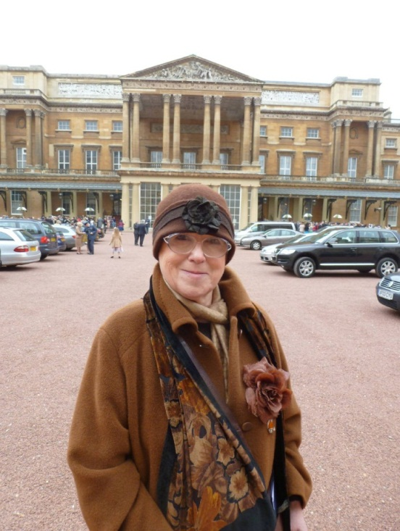
Silvana Malle

Lisl in Washington
Lisl Biggs-Davison had the pleasure of meeting up with old friends in October when visiting Virginia. Some days were spent near the Blue Ridge Mountains with Natasha and Joel at their home in Haymarket (when they are not in Croatia), which included a visit to Mount Vernon. Whilst in D.C. there was an enjoyable visit to Sebastian and Katie Gorka in McLean, and my final evening was spent with Bob, Blanca and the family.
Earlier in the day I met up with Bob at the Rayburn House Office when he took the chair in a lunchtime debate entitled Debating the Freedoms America Promotes and organised by the Common Sense Society, which was originally founded in Hungary.
http://commonsensesociety.com/
Bob showed me around Georgetown and Georgetown University. There we met Father James Schall, a Jesuit in his 80s, who is still teaching and is obviously held in great affection and high esteem. Bob mentions him in the CRCE Briefing Paper – The Roots of Islamist Ideology.
Recommended Reading
Iron Curtain: The Crushing of Eastern Europe 1944-1956 by Anne Applebaum
(Allen Lane, 2012)
All over central Europe fledgling elements of civil society – clubs, associations, schools and churches – were co-opted into new, Soviet-occupied communist states. How did this happen, and why did the Soviet Union’s attempt to impose totalitarianism on its new empire ultimately fail? These are the questions that lie at the core of Anne Applebaum’s illuminating new book.
From The Economist: http://econ.st/RKkREA

From Late Socialism to a Private Law Society by Bruno Schönfelder
(Berliner Wissenschaftsverlag, 2012)
The author of the Technical University Freiberg serves on CRCE’s Editorial Board.

Estonia: a case study: how and why Estonia embraced austerity by Ryan Bourne
(Centre for Policy Studies London, 2012)

Srebrenica
From Keith Miles OBE, Letter in The Guardian, Sunday 22 July 2012:

I can agree wholeheartedly with the sentiments expressed in Professor Vernon Bogdanor's article (Srebrenica: Britain's guilt, 13 July). As a trustee of a charity dealing with rehousing many families who suffered as a result of the Srebrenica massacre, I am very aware of the human consequences of Douglas Hurd's policy. Also, it is something of a mystery why he resigned just two weeks before the
massacre took place and subsequently acted as an adviser to National Westminster Bank for business with Milosevic.
However, while praising this excellent article, may I express one reservation? This is its use of the currently popular phrase "the worst atrocity in Europe …since the Holocaust". This is not accurate, because the massacre in June 1945 of 12,000 anti-communist Slovenes by Tito's forces took place after the end of the Second World War indeed the total figure of his massacres is now coming clearer because the government of Slovenia has been discovering and opening the hidden graves on its territory, and these number nearly 600 graves containing an estimated 100,000 bodies. There are undoubtedly more in the rest of former Yugoslavia.
After Tito was expelled from the Cominform by Stalin, it suited the west's cold war purpose to play down his terror of the years 1945-48. Now that the cold war is over, we need to not only re-examine the facts but be careful with popular phrases. This is especially important because the Srebrenica massacre was almost a carbon copy of the earlier modus operandi. Now that the Yugoslav and other archives are becoming available it is important that the historic record be clarified, and we are asking that a joint British-Slovene Historic Commission be set up.
Keith Miles, British-Slovene Society and Advisory Council, CRCE.

Pixel, observer at the Slovene Colloquium.

The CRCE Newsletter
© Centre for Research into Post-Communist Economies 2013

