A New Trustee for the Centre
We are delighted to welcome Susan Sirc to the Board of Trustees. Sue is well known to friends and colleagues and, with Ljubo Sirc our founder, has been involved with the CRCE for many years.

London Meeting
Masha Karp, former Russian Features Editor of the BBC, gave a fascinating talk in May on Unilateral Disarmament: How the West Has Destroyed Its Broadcasting to Russia
http://www.rightsinrussia.info/archive/blog/masha-karp/western-broadcasting

Philip Hanson was in the chair and Helen Szamuely provided delicious Central European Snacks. See also Helen's blog: http://yourfreedomandours.blogspot.co.uk

Recently Published

The Lure of State Capitalism is available - a selection of transcripts and papers from the 2012 colloquium.

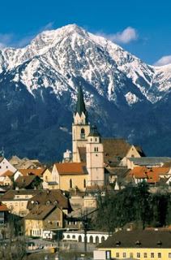
Kranj, Slovenia
The conference took place nearby

Contributors include: Philip Hanson, Stefan Hedlund, Olga Kuznetsova, Silvana Malle, Tomasz Mickiewicz, John H. Moore, Svetozar Pejovich, Robert R. Reilly, Roger Sandilands & Rok Spruk.

Topics covered:
"The limitations of economics as a guide to the choice of economic institutions and prediction of fundamental change"

"Relations between business and the state in liberal theory in Russia and elsewhere"

"Pros and Cons of State Capitalism – with examples of Asia, Russia, South America & Europe" http://www.crce.org.uk/publications/

New Briefing Paper
Social Capital and the Challenges of Global Transformation by Professor Vladimir Mau, April 2013, Price £10. Offer Price: £7.

Post-Communist Economies at 25
The first issue of CRCE’s prestigious journal appeared in March 1989, its original title was Communist Economies. The Editor throughout this quarter century is the indefatigable Roger Clarke. The first published authors and their subjects may well be of interest and were:

"Socialist Economies, Economic Reforms and Economists: Reflections of a Czechoslovak Economist" by Vaclav Klaus;

"STE-LDC Comparisons: a Neglected Field of Comparative Systems Analysis" by Jan Winiecki;

"Some Lessons from Two Decades of Economic Reform in Hungary." by Laszlo Csaba;

"Socio-Economic Reforms in Eastern Europe and Real Socialism" by Jan Mujzel;

"On Economic Reform in Socialist Countries: The Debate on Economic Calculation under Socialism Revisited" by Gabriel Temkin;

"National Resources Development: An Economic and Environmental Problem in the USSR" by Zeev Wolfson;

"The Extremist Path of Economic Development in Eastern Europe by Kalman Pecsi";

"Economic Efficiency and Reform" By Jozsef Bognar

"First Signs of Solidarity in the Soviet Union" Will by John McCarthy.

This year's January and March issues of
Post-Communist Economies are now available.

Lessons of History
We hope that our readers will look at the History page on our website which has reports on communist crimes and also listed sites of mass graves in Slovenia.
http://www.crce.org.uk/lessons/

There is now a recently created Wikipedia article with up-to-date information which will be of interest, especially the table with the clickable links
http://en.wikipedia.org/wiki/Mass_graves_in_Slovenia

Recommended Reading
Becoming Europe by Samuel Gregg,
Director of Research at the Acton Institute.
Mr. Gregg examines economic culture – the values and institutions that inform our economic priorities – to explain how European economic life has drifted in the direction of what Alexis de Tocqueville called "soft despotism" and the ways in which similar trends are manifesting themselves in the United States.
Encounter Books, New York, 2013

Can Russia Modernise? – Sistema, Power Networks and Informal Governance by Alena V. Ledeneva, Professor of Politics and Society, SSEES, University College, London.

Concentrating on Vladimir Putin's system of
governance – referred to as systema – the
author identifies four key types of networks:
his inner circle, useful friends, core contacts
and more diffused ties and connections. These networks serve systema, but also serve themselves…
Cambridge University Press, Cambridge, 2013

Farewell to Freedom's Friend

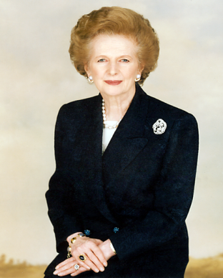
Margaret, Baroness Thatcher
1925-2113

In April, Her Majesty the Queen and many heads of state attended the funeral in St Paul's, including Czech Republic's Prime Minister Petr Necas and former President Vaclav Klaus; from Poland former President Lech Walesa and Prime Minister Donald Tusk and Hungary's Prime Minister Viktor Orbán. By their presence, they paid tribute to Lady Thatcher for her role in the dismantling of the Iron Curtain and in ending the Cold War.
See CRCE's tribute to Lady Thatcher from: Géza Jeszenszky, Foreign Minister of Hungary (1990-94), Silvana Malle, Professor Emeritus, University of Verona, Tomasz Mickiewicz, Aston Business School, Natasha Srdoc, Adriatic Institute for Public Policy, Rijeka, Jan Winiecki, National Bank of Poland, and from Keith Miles OBE, an article published in Finance, Ljubljana: ‘How Thatcherism could save Slovenia: Margaret Thatcher: Herald of Freedom’ http://www.crce.org.uk/news/
The CRCE Newsletter
© Centre for Research into Post-Communist Economies
2013

