CRCE Autumn Colloquium in Slovenia

We discussed: Filling Institutional Voids: Market Self Organisation, Informal Sector or Organised Crime. Among our distinguished speakers were Alexander Chepurenko from Russia, Norma Rossi from Italy, and Arnis Sauka from Estonia.

We are grateful to Rok Spruk for the following kind words:
"It was a wonderful conference - well-organized, precise, up-to-date with lots of new insights and fruitful conference contributions and I much enjoyed discussions with everyone.

What I really admire about CRCE's conferences is the open platform and the participation which allows open, direct, critical and sometimes polemical exchange of ideas. No participant is excluded from the discussion, and which is pretty rare in the contemporary academic world, notwithstanding the top universities where such discussions frequently converge into the battle of power and status."

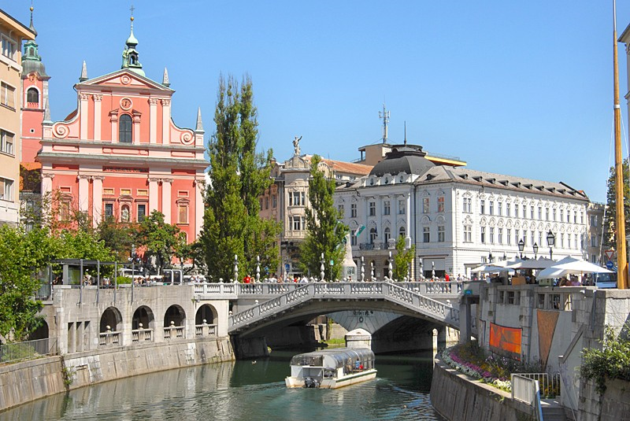
Ljubljana, Slovenia's capital city

Afterwards, some participants visited Ljubljana and others had tea in Kranj with Ljubo Sirc's cousin Darja Okorn and saw the famous Monga.

Recently Published

A CRCE Briefing Paper, Hoodwinking Churchill by Peter Batty. £10 (£7.50 to our readers)

The author is a newspaper journalist who was also the editor of BBC TV’s Tonight programme. He scripted and produced six episodes of the internationally praised TV series The World at War. At the time of the break-up of Yugoslavia he made two films on Tito for the BBC which proved controversial and led to his book, Hoodwinking Churchill, Tito’s Great Confidence Trick, Shepheard-Walwyn, London, 2011, highly recommended. See: CRCE Newsletter No 42
http://www.crce.org.uk/news/

New to the Website

Encouraging Entrepreneurship in Eastern Europe by Andrzej Brzeski et al. New Series 22, September 2006.
http://www.crce.org.uk/publications/

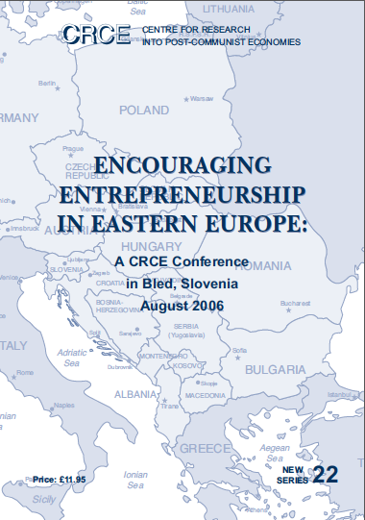

Post-Communist Economies

Articles in the June issue include: The public utilities, war and corruption in Ukraine; The role of non-tariff measures in EU dairy trade with Russia, and Micro-finance institution activities in Central Asia: a case study of Tajikistan and Uzbekistan.

In the September issue: The role of corporations in economic development: Albania on its way to internationalisation; Economic freedom, democracy and economic growth: a causal investigation in transition countries, and Myanmar's last two decades of partial transition to a market economy: a negative legacy for the new government.
http://www.tandf.co.uk/journals/carfax/14631377.html.
Canon Timothy Russ
11 August 1943-29 June 2013

From the tribute by Keith Miles, OBE:
Timothy Russ, who died peacefully on the feast of St Peter and St Paul, came from an old Catholic family and looked back to his forebears, the Huddlestons, with great pride. His family legend traced their Englishness back to the Anglo-Saxon King Athlestan in the 10th century.

After Cambridge he studied for the priesthood, was ordained in 1972 and became assistant priest in St Lawrence Cambridge and St Martin Luton. He then became secretary to Bishop Charles Grant. Tim felt great affinity with Bishop Grant, who was born in Cambridge where the Huddleston ancestral home, Sawston Hall, is located.

He served as Parish Priest in Burnham, and from 1996 at the Church of The Immaculate Heart of Mary, Great Missenden.

In recent years, Tim arranged for locum priests from Slovenia to run the parish during his annual three-week summer leave. As a result of this connection, he became aware of the massacre of young Slovene Catholic soldiers by the Communists in 1945 after being returned from Austria by the British Army. This inspired him to organise a special Mass of Reparation to bring reconciliation and give a spiritual compensation from the United Kingdom for the mistake made in returning these young men.

The Bishop of Northampton, the Anglican Bishop of Buckingham, the Archbishop of Ljubljana and many other dignitaries participated in the service held in Great Missenden, which was filmed for Slovenian TV. Cardinal France Rode, who lost a brother in the massacre, sent a personal message from the Vatican.

Tim felt that this was one of the more important things he did in life. One of those who took part said: ‘celebrating the Reparation Mass was an important historical event, not only for all those who were present, but also for the relatives of those hundreds of thousands of victims in 1945, who will always remember his name.’
http://www.britishslovenesociety.org/obituary-canon-timothy-vincent-russ-11-8-1943-29-6-2013/

Tadeusz Mazowiecki
18 April 1927-28 October 2013

He was Eastern Europe's first democratic prime minister after communism and key adviser to Poland's Solidarity freedom movement.
President Bronislaw Komorowski said the Poles should think with gratitude about everything that has happened in Poland since 1989, when Mazowiecki took office.
Lech Walesa said it was a "pity that such great people are dying. We could have used his wisdom today, when democracy is not so perfect."
Tomasz Mickiewicz writes: "He was a man of principle and also deeply religious. He was both open and ready to engage in patient discussion with everybody willing to talk, never aggressive, yet very stubborn when it came to things that mattered to him. There have been fascinating discussions about him on Polish TV since his death with his friends and colleagues.

One of them recalled the autumn 1989 when Gorbachev invited Mazowiecki to Moscow, where he was asked to place flowers at the Lenin mausoleum. Against many people's advice he refused.

His government was probably the best Poland has had in its recent history".

The CRCE Newsletter
© Centre for Research into Post-Communist Economies
2013

