Communist Symbols Survey
We thought it would be a good time to compile a comprehensive record of the ways different counties have dealt with the transition from a communist society to a free society, in particular how symbols of communist rule and power have been abolished, changed, destroyed, or otherwise dealt with.

We wrote to Embassies and Government Departments in thirty countries in Eastern Europe and the former Soviet Union. We received a swift response from a few. Several surveys were passed on to institutes which enthusiastically completed them.

However, in most cases we received no response, even after second and third time of asking - perhaps a problem of language? We followed up in a few cases with requests to individual friends and colleagues, who supplied the information, for which we are most grateful. We hope information on other countries will be forthcoming.

We should like to express our gratitude to Annie Beadle who sent out dozens of emails and letters at the start; and to students who collated all the data and designed the chart.

Alexandros Petersen
Lisl Biggs-Davison writes: at the end of January, we received the shocking and distressing news that Alexandros Petersen had been murdered in Kabul in a Taleban bomb blast. Alex had just taken up a professorship at the American University, after having worked in many parts of the world, most recently at the Jamestown Foundation in Washington DC. We somehow don't expect a person known to

us to be killed by the Taleban; although I knew quite a few killed by the IRA, so it felt very bitter indeed to learn of Alex's death.

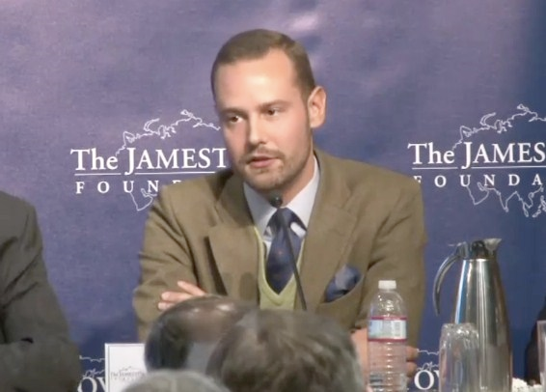
Alex at the Jamestown Foundation

As my colleague Helen Szamuely rightly comments: "Afghanistan desperately needs people like Alex".
I first met Alex seven years ago when he was reading a Ph.D. at the LSE. He attended CRCE events and also gave a talk here on the Caucuses. Read his CRCE Paper http://www.crce.org.uk/publications/security-and-western-integration-in-the-caucasus/

All at the CRCE send sincere condolences to his family.

Post-Communist Economies -25 Years
To mark the 25th volume of Post-Communist Economies, the Editor Roger Clarke has selected 12 key articles to highlight. These are free to read online until the end of May 2014.
Roger Clarke has also written a note on the history of the journal since its publication:
My brief was to choose ten articles to be highlighted: this sounds simple enough until I calculated that twenty-five volumes meant one hundred issues…The decision to launch the journal was made in the spring of 1988, when ‘reform’ was very much in the air but neither scholars nor politicians anticipated the imminent collapse of the communist regimes and the economic transformation that began less than two years …The early volumes are therefore substantially different from recent ones in terms of the subjects treated and the twenty-five years can be seen as a development path… I will not comment on individual articles, though I cannot resist recalling that the March 1990 issue, with contributions from the finance ministers of Poland and Czechoslovakia, brought the young journal a mention in the Financial Times.
To access entire note and articles go to: http://explore.tandfonline.com/content/pgas/cpce-anniversary/
News Item: Death of Mitja Ribičič
(19 May 1919 – 28 November 2013)
"Ribicic was a Slovenian Communist official, and Yugoslav politician. He was the only Slovenian prime minister of the Socialist Federal Republic of Yugoslavia (1969–1971). Between 1945 and 1957 he was at the top of the repressive system in Slovenia, and was accused of violations of human rights and crimes against humanity". Dr Ljubo Sirc, CRCE's founder, a co-defendant in the 1947 show trials, suffered under Ribicic's regime.
Friends throughout the world sent messages to Dr Sirc at the news of Ribicic's demise, among them Silvana Malle, who beautifully expresses their thoughts:
‘Mitja Ribicic is gone, but not with justice. That Ljubo is still with us is more than justice. It is a treasure to all his friends dispersed all over the world. Surely something MR could never dream of.’
For background information, read Ljubo Sirc's autobiography, Between Hitler and Tito, Andre Deutsch, London, 1989.
Further reading: by Tibor Szamuely http://archive.spectator.co.uk/article/21st-february-1970/7/yugoslavia.
&
Portrait of a Political Policeman by Ljubo Sirc
http://www.crce.org.uk/briefings/brief7.shtml

CRCE Website
New to the website: An interview with Dr Sirc in the Slovenian newspaper, Vecer. http://www.crce.org.uk/lessons/
As we go to press the crisis in the Ukraine expands and worsens. One of the Opposition leaders from Kiev visited the CRCE in early February for discussions.
It is more than worthwhile to read another paper by the always prescient Ljubo Sirc, and this one gives us a useful reminder:
Communists Favour World Disorder http://www.crce.org.uk/briefings/sirc.shtml

Congratulations to Natasha Srdoc
Natasha took the US Oath of Allegiance on Ronald Reagan's Birthday, on February 6th and is proud to join husband Joel and son David as an American citizen.

The CRCE Newsletter
© Centre for Research into Post-Communist Economies
2014

