The Autumn Colloquium
The Ukraine Crisis: Sovereignty, Borders and Economic Interests in
Ex-communist Europe
The CRCE's Colloquium was held in the beautiful village of Preddvor in Slovenia.

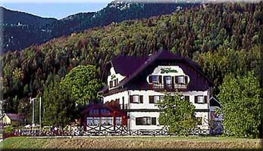
Pension Zaplata – the Colloquium Hotel

Our student guest Irina Ilieva writes: “During the first day of the event I was extremely excited to participate in a round-table discussion with so many distinguished speakers from various fields. I was quite fascinated by the ease of communication, and the professionalism of all the participants.

I was most attracted by the conference topic The Ukraine Crisis: Sovereignty, Borders and Economic Interests in ex-communist Europe, Russia and Ukraine, as well as within the European Union.

During the discussions, noting down important points, I immensely broadened my horizons not only about the situation in Ukraine, but also the way measures have already been implemented and analysed by the participants at Preddvor: Those included tackling issues on collective rights, conflicts and border challenges in other conflict situations, drawing parallels to what was done after the break-up of Yugoslavia and Czechoslovakia.

Particularly intriguing were the panel sessions on the economic aspects of the crisis in Ukraine – the consequences of Russia’s Customs Union and the European interests at stake, as well as the role of media in shaping public opinion. Oleg Manaev, a Belarusian sociologist and founder of the IISEPS, shared statistical data that illustrated to what extent Belarusian and Russian society has been influenced by television and radio and the views promoted on the conflict.

Apart from the sessions, I managed to discuss other topics that concern everyone in post-communist Europe, including ethnic conflicts and minority rights with a historian, and border control and smuggling with a specialist in the field of Independent Risk and intelligence. I found it very rewarding that everyone treated me equally and were interested in my views”.

A CRCE Webbook
Filling Institutional Voids: Market Self Organisation,
Informal Sector or Organised Crime
Extracts from the 2013 Colloquium
Visit: http://www.crce.org.uk/publications/

Post-Communist Economies
Numbers 3 and 4 of the 2014 Journal are available with articles on many countries, including China, Croatia, Russia, Slovakia, Ukraine and Uzbekistan.

Visit: www.tandfonline.com/loi/cpce20

Farewell to Two Friends
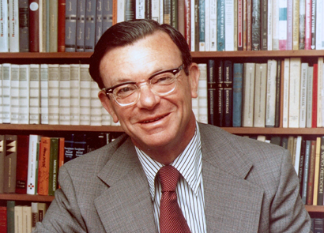
We were saddened to learn of the death in August of Gregory Grossman at the age of 93. Greg served on our Advisory Council. As the obituary posted by U C Berkeley states, he was "considered a towering figure in the study of the Soviet economy who shaped the thinking of generations of scholars”. We also remember a very gracious person.
He was born July 5, 1921, in Kiev, Ukraine. In early 1923 the family fled the post-Russian Revolution chaos and famine and took a month-long journey on the Trans-Siberian Railway to Harbin, Manchuria. After completing high school in 1937 in Tientsin, China, he boarded a Japanese ocean liner to attend Berkeley.
During World War II, Grossman served as artillery observer with the 731st Field Artillery Battalion during the Battle of the Bulge.
http://newscenter.berkeley.edu/2014/08/25/authority-on-soviet-economy-gregory-grossman-passes-away/
Greg wrote a most thoughtful review (available on request) of the Festschrift for Ljubo Sirc, A Liberating Economic Journey: Post-Communist Transition. Essays in Honour of Ljubo Sirc. Editors: Andrzej Brzeski & Jan Winiecki, Centre for Research into Post-Communist Economies, 2000.

We are also grieved to report to the death in October of Leonard Liggio at the age of 81. He was Executive Vice President of Academics at Atlas Network.
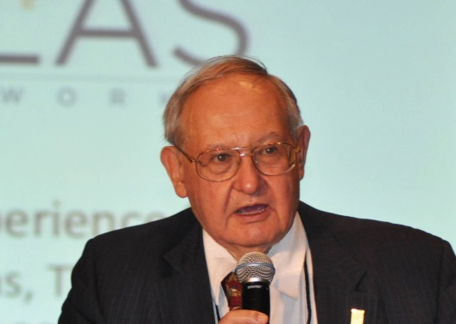
Leonard’s career advancing liberty spanned seven decades, during which time he served as the President of the Mont Pelerin Society, the Philadelphia Society, and the Institute for Humane Studies, where he later continued to serve as its Distinguished Senior Scholar. He was a professor at George Mason University, a visiting professor at the Universidad Francisco Marroquín, a board member of the Competitive Enterprise Institute, and a Trustee of Liberty Fund.
http://www.atlasnetwork.org/news/article/in-memoriam-leonard-liggio

Twenty-five years after
The Wall came down
For the 20th Anniversary CRCE published Fall of the Berlin Wall – Recollections 20 Years On, by Géza Jeszenszky and Krassen Stanchev. A CRCE Briefing Paper – worth reading!

CRCE – The First Year
Thirty years ago, the CRCE published its first book: Market or Plan? by Milton Friedman, with a Comment by Alec Nove.

The CRCE Newsletter
© Centre for Research into Post-Communist Economies
2014

