Ljubo Sirc

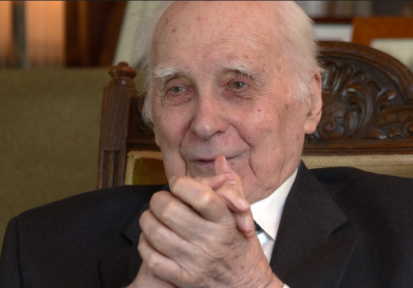

An interview with Ljubo Sirc has been shown on Slovenian TV. The television group led by Joze Mozina visited Glasgow to film the interview over several days.
http://www.casnik.si/index.php/2015/02/10/pricevalci-ljubo-sirc/

Since then, Dr Joze Dezman has written an article based on the much of the interview in the Slovene weekly, Reporter.

December Meeting
The final event of the year focused on:
'Russia's Ukrainian Adventure: Military Aspects & the Implications for Russian Domestic Politics & Russian Economy'

Leading the discussion were Philip Hanson OBE, CRCE trustee and Chatham House Fellow, Igor Sutyagin from RUSI & Elizabeth Teague OBE, formerly FCO.
Iain Elliot OBE was in the chair.

The Evening was a great success with the well-informed audience, and Helen Szamuely's delicious Central European Snacks were much appreciated. However, it is a disgrace that Russia's aggression in Ukraine continue.

At time of writing this newsletter I recall that it is 13 months since the visit to Tufton Street by a member of the Ukrainian opposition. He foretold that the situation would be as serious as it is now.

We have also seen the murder in Moscow of Boris Nemtsov, who was a colleague of our great friend, the late Yegor Gaidar. Indeed, some of us met Boris, and we extend our condolences to his family.

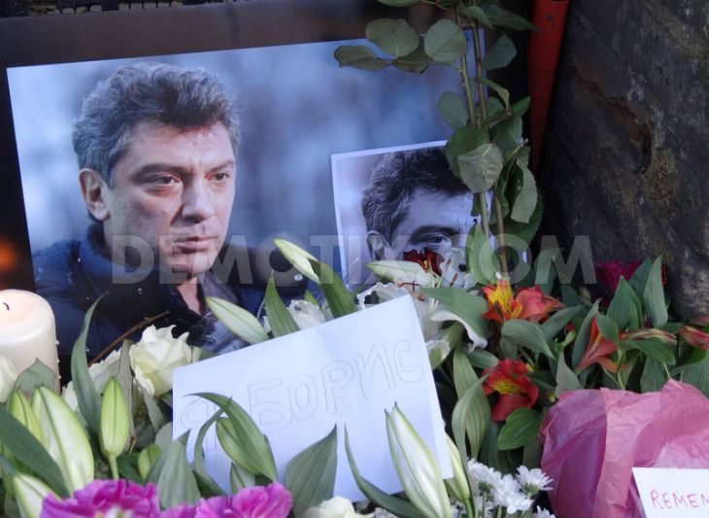
From A Memorial Gathering for Boris Nemtsov

Twenty-five years after
The Wall came down
New to the Website: The Fall of the Berlin Wall – Recollections 20 Years On by Géza Jeszenszky and Krassen Stanchev. This was published for the 20th Anniversary. A CRCE Briefing Paper – worth reading!
http://www.crce.org.uk/briefings/brief19.shtml

Post-Communist Economies
The first issue of the 2015 Journal is available (volume 27). Articles include: Trade in Services and Tertiarisation of the Visegrad Four Economies; Opportunities for Fiscal Devaluation in Small Open Economies: the Case of Ukraine and In Search of the Elusive Chinese Urban Middle Class: an Exploratory Analysis. Visit: www.tandfonline.com/loi/cpce20

Dennis O’Keeffe 1939 – 2014
Friend and supporter of CRCE
& its work

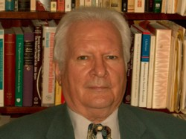

Helen Szamuely writes: Dennis O’Keeffe died not long before Christmas 2014, having, sadly, spent the last three and a half years of his life in a nursing home after a very serious accident. During that period I visited him on a number of occasions and each time the conversation sooner or later turned to a discussion of what was happening in Eastern Europe and some account was required about the recent activities of CRCE. Dennis rejoiced in many of the developments in countries he had visited when they were behind the Iron Curtain and felt with some justification that he, too, had contributed to those developments.

As a boy of 13 Dennis had come across Arthur Koestler’s Darkness at Noon and the book left a life-long impression: he always maintained that his hatred for totalitarianism in any form dated from that reading. Nor was that hatred merely theoretical. Dennis struggled against various totalitarian ideas in the West and he became closely involved in the organizations that helped intellectuals in Eastern Europe (then under Soviet and Communist domination) to learn and develop other ideas.

As part of the Jagiellonian Trust, set up by his friend and colleague, Roger Scruton, Dennis travelled several times to Poland and Czechoslovakia, taking forbidden books and documents with him. He also lectured at the underground universities and took part in fruitful discussions with various academics and intellectuals in those countries. There can be no question that he and others who did the same ran a good deal of risk from the local authorities (some were arrested and interrogated at length) but Dennis and his colleagues assumed that this risk was worth running for the sake of freedom.

Back in London Dennis took part in many meetings and discussions and was often to be seen at CRCE events before and after the fall of the Soviet Union, chatting, joking and contributing from his own fund of knowledge and understanding. In September 2004 he was part of a panel that discussed the phenomenon of Samizdat in the Soviet Union and Eastern Europe as well as its influence in the West. As ever, Dennis’s contribution was fascinating and dealt with his experiences in Poland and Czechoslovakia. (The transcript of that discussion is available from CRCE as its Occasional Paper No. 13, Samizdat.)

The collapse of the Soviet Empire and the liberation of Eastern Europe owes a great deal to the work of people like Dennis O’Keeffe, who, alas, will no longer be there to talk and joke and tell stories at CRCE events. We shall miss him.

In Memory of Alexandros Petersen
The Central Asia Programme, at George Washington University in Washington DC, is working on a project to republish a number of Alexandros Petersen's works to mark the first anniversary of his death - January 17th. Security and Western Integration in the Caucasus, A CRCE Briefing Paper based on a talk, Alex gave at the Centre in 2007, will be included.

The CRCE Newsletter
© Centre for Research into Post-Communist Economies 2015

