Birthday Greetings to Ljubo Sirc

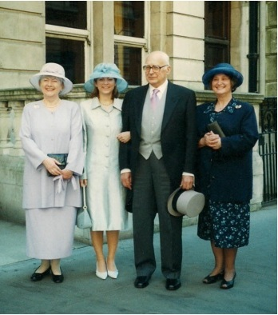
Sue, Nadia & Ljubo Sirc CBE, and Cousin Darja Okorn, the day of his investiture in 2001

Ljubo Sirc celebrated his 95th birthday in April, and sends his grateful thanks and warmest regards to the very many friends throughout the world for their cards and messages. E-mail messages were copied onto fine paper and have been collected into an album with letters and cards.

Krassen Stanchev in London

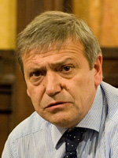

Krassen Stanchev led an evening discussion at the CRCE on “The Ukraine - Russia Conflict: What should the EU do next?” Philip Hanson OBE was in the Chair. We meet Krassen in Slovenia each year and it was a great pleasure to welcome him to the Centre, where he met many of our British-based colleagues and enjoyed Helen Szamuely's famous Central European Snacks.

New Web Book
The Ukraine Crisis: Sovereignty, Borders and Economic Interests in Ex-Communist Europe - Extracts from the 2014 CRCE Colloquium. In the light of the crisis we discussed sovereignty and the sanctity (or otherwise) of international borders in ex-communist Europe. Not primarily an economic topic but one that for obvious reasons we should consider as a strong possibility. The examples could include the breakup of Yugoslavia, the independence of Kosovo, Abkhazia, South Ossetia, Pridnestrov'ye, Chechnya, and Crimea. Two of the presentations: “Hungary, NATO and the War in Ukraine”, by Géza Jeszenszky and “Ukraine: political and security aspects of the crisis”, by Oleg Manaev are now on the Publications page of the website: http://www.crce.org.uk/publications/
More will soon be available.

Post-Communist Economies
The June issue of the 2015 Journal is available. Articles include:
“Russia’s flat tax reform: redefining its effects on employment”, and “A note on poverty among ethnic minorities in the Northwest region of Vietnam”
Visit: www.tandfonline.com/loi/cpce20

A CRCE Briefing:
An Interview with Oana-Valentina Suciu
Our latest Briefing Paper is based on an interview with Oana Suciu by the Slovenian newspaper Delo in February this year. Oana is an assistant professor at the University of Bucharest. Many colleagues will remember Oana from CRCE conferences.

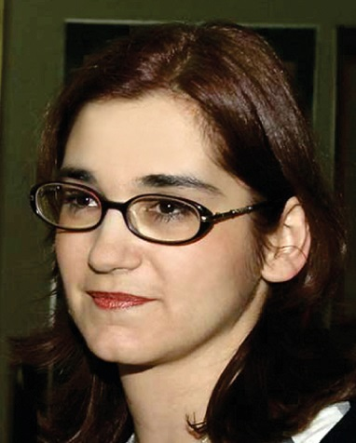
Oana Suciu

Ingrid Gregg
CRCE received a most welcome visit from Ingrid Gregg, President of the Earhart Foundation. She and Lisl were able to discuss much of mutual interest. We should like to congratulate her on being elected President of the Philadelphia Society.

News from Slovenia
Darja Okorn, Ljubo’s cousin, gave a talk at the Kranj Museum in May about the town before & after WW2. She called it 'Gentlemen & Comrades'. It seems that it was so highly thought of that the weekly Reporter interviewed her, and the publishers of an annual book on the region want to include her talk in the next issue. Amongst other topics she talked about the lively pre-war commercial sector with small businesses all over Kranj: there were in excess of 120! Darja's talk is very topical in the light of lack of privatisation in Slovenia at the moment.

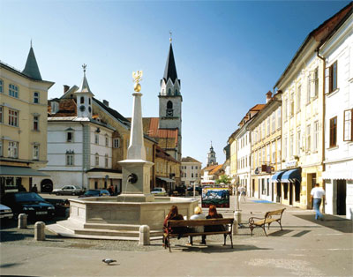
Kranj, home of Ljubo Sirc

The Russian Challenge It is now clear that Russia, on its present course, cannot be constructively accommodated into the international system. The combination of its weakening economy and a political culture that stifles enterprise and society imperils both security in Europe and stability in Russia. The ongoing crisis in Ukraine, in part the result of the West's laissez-faire approach to Russia, demonstrates the need for a new Western strategy. In the report from Chatham House, The Russian Challenge, Keir Giles, Philip Hanson, Roderic Lyne, James Nixey, James Sherr and Andrew Wood argue that a new strategy towards Russia must recognize this.

European Atlantic Group – EAG The European-Atlantic Group, a non-aligned, all party, registered charity founded in 1954, is renowned as one of the foremost platforms for high level interaction in the field of international relations. New members always welcome. For further details: http://www.eag.org.uk/

The CRCE Newsletter
© Centre for Research into Post-Communist Economies 2015

